GREENHILL ACADEMY
CONTINUOUS ASSESSMENT(SET 3), 2016
INTEGRATED SCIENCE
Time Allowed: 2 Hours 15 Minutes
Index No.
Candidate’s Name: ............................................................................................................
Candidates Signature: ......................................................................................................
District Name: ....................................................................................................................

Read the following instructions carefully: | FOR EXAMINERS’  USE ONLY
- The paper has two sections A and B. | QN.NO. | MARKS | EXR’S NO.
- Answer all questions. All answers to both | 1 – 10
Sections A and B must be written in the | 11 – 20
Spaces provided. | 21 – 30
- All answers must be written using a blue or black ball-point pen or ink. | 31 – 40
- Unnecessary changes of work may lead to loss of marks. | 41 – 43
- Any handwriting that cannot easily be read | 44 – 46
may lead to loss of marks. | 47 – 49
- Do not fill anything in the boxes indicated | 50 – 52
“For Examiners’ Use Only” and those | 53 – 55
Inside the question paper. | Total

SECTION A (40 marks)
- Mention any one state of matter.
_________________________________________________________________
- Identify any one health habit that should be practiced by a P7 person after visiting a latrine.
_________________________________________________________________
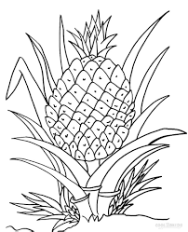
The diagram below shows a plant. Study it and answer question that follows.
T

- How is part T useful to the plant shown above?
_________________________________________________________________
- Give any one health activity carried out to a pregnant woman at the ante-natal health care clinic.
_________________________________________________________________
- How can one reduce the strength of an electro magnet?
__________________________________________________________________
- What is the role of a root cap to plants?
__________________________________________________________________
- How is the screen of a pinhole camera and the retina of the human eye similar in the way they function?
__________________________________________________________________
- Name any one instrument that uses mercury.
_________________________________________________________________

- Which substance is formed when vapour is condensed?
_________________________________________________________________
- How are young farmers clubs useful in a school?
__________________________________________________________________
- Why do some cooking utensils have handles covered with wooden materials?
__________________________________________________________________
- Mention any one cultural practice that hinders the control of AIDS in Uganda.
__________________________________________________________________
- Which immunisable disease is controlled by B.C.G vaccine?
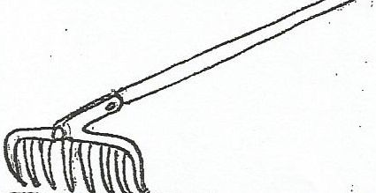
___________________________________________________________________
The diagram below shows a living organism. Use it to answer questions that follow.
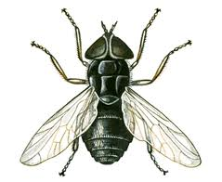
X

14. How is part marked X important to the above organism?
_________________________________________________________________
- State any one physical change caused by heat.
_________________________________________________________________
- Give the purpose of teaching children about PIASCY.
________________________________________________________________
- Suggest any one antisocial behavior that results from drug abuse.
__________________________________________________________________

- Why are people discouraged from touching electric wires and poles that have fallen on the ground?
_________________________________________________________________
- Why are food taboos dangerous in a community with very poor people?
___________________________________________________________________
___________________________________________________________________
- Mention any one way a P.7 child can help a brother to avoid faecal diseases?
__________________________________________________________________
- What is the importance of keeping farm tools in dry places?
__________________________________________________________________
- Why is a duck billed platy pus grouped under mammals?
___________________________________________________________________
___________________________________________________________________
- Why does food go bad when a housefly lands on it?
__________________________________________________________________
- Identify the form of energy that can enable a farmer to separate a bean seed from it’s husks.
__________________________________________________________________
- The diagram below shows a blood cell. Name it.

__________________________________________________________________
- Name any one type of poultry.
__________________________________________________________________
- What name is given to a mixture of two or more metals chemically combined?
__________________________________________________________________

- Write the use blood vessels in the tooth?
__________________________________________________________________
- Why are gaps left in soda bottles?
_________________________________________________________________
- Why is chlorine added to water for drinking?
__________________________________________________________________
Study the diagram and answer questions that follow.
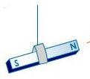
- How is the property drawn above useful to people?
_________________________________________________________________
_________________________________________________________________
- Name any one natural manure.
_________________________________________________________________
- How can people control the bad smell in pit latrines?
__________________________________________________________________
- How do mushrooms get their food?
__________________________________________________________________
- Why are polythene bags being discouraged in our country?
_________________________________________________________________
- Why is a deep litter poultry system recommended in urban areas than free range system?
__________________________________________________________________
__________________________________________________________________

- Mention any one activity that promotes personal hygiene in schools.
__________________________________________________________________
- How is the work of the kidneys similar that of a sieve? _________________________________________________________________
- State the importance of maggots in a pit latrine.
_________________________________________________________________
- Give the device installed in an electric circuit to safe guard the house from electric fires. _________________________________________________________________
SECTION B (60 marks)
41. The diagram below shows balloons A and P tied on a beam balance.
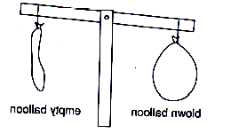
Use it to answer questions that follow.

A
A
P

a) Write the properties of air shown in the diagram above.
_________________________________________________________________
b) Identify the instrument on which the balloons are tied.
__________________________________________________________________
c) If that beam balance was left in the sun for some time, what would happen to
balloon A?
_________________________________________________________________
42 a) Give any one dairy breeds of goats kept in Uganda.
__________________________________________________________________
(b) Why do farmers rear goats?
(i) ________________________________________________________________
(ii) ________________________________________________________________
(c) How can diseases in goats be controlled?
________________________________________________________________
43. Match the vectors in list A to their diseases in list B correctly.
List A List B
Simulium flies typhus fever
Bedbug dengue fever
Tsetsefly relapsing fever
Tiger mosquito sleeping sickness.
river blindness
List A List B
Simulium flies _____________________________________
Bedbug _____________________________________
Tiger mosquito _____________________________________
Tse tsefly _____________________________________
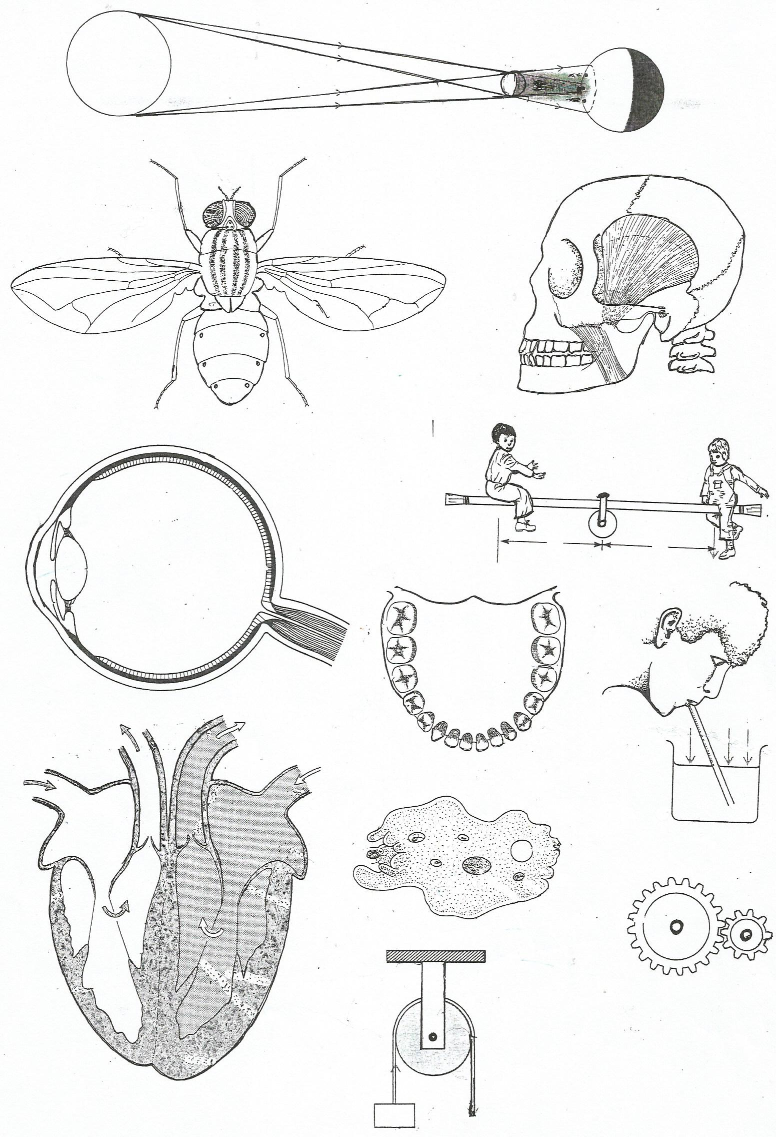
44. Below is part of the human skeleton. Use it to answer the questions
that follow.
X
R

a) Name part marked X.
___________________________________________________________________
b) Identify the part of skeleton shown above.
___________________________________________________________________
c) Name any two organs protected by the part drawn above.
(i) _________________________________________________________________
(ii) ________________________________________________________________
45. a) State any two ways how a person mixing ORS can prevent contaminating
the solution.
i)__________________________________________________________________
ii)__________________________________________________________________
b) Mention the two most important solutes used when mixing ORS.
i) ________________________________________________________________
ii) ________________________________________________________________
46. In which way are vertebrates different from invertebrates?
_________________________________________________________________
__________________________________________________________________
b) Apart from amphibians, suggest any other two examples of cold blooded animals.
(i) ________________________________________________________________
(ii) _______________________________________________________________
c) Give one reason why amphibians lay many eggs.
_________________________________________________________________
47. The diagram shows a tool used in oral health. Use it to answer the
questions that follow.


a) Identify the above item.
__________________________________________________________________
b) Mention the body organ cleaned using the above item.
__________________________________________________________________
b) Which element of P.H.C is promoted using the above item?
__________________________________________________________________
c) Besides the above item, which other material can used to keep prevent tooth decay
____________________________________________________________________
48. (a) State any one effect of heat on matter.
____________________________________________________________________
(b) Why is space left between rails during construction of railways?
____________________________________________________________________________________________________________________________________________
(c) What makes soda bottles to crack when it is left in a refrigerator for three days?
____________________________________________________________________________________________________________________________________________
(d) How does heat travel through water?
______________________________________________________________________
49. (a) What are anti-social behaviours?
____________________________________________________________________________________________________________________________________________
(b) Write any one anti-social behaviour.
______________________________________________________________________
(c) Give any two ways of controlling anti social behaviours in your school.
(i) ____________________________________________________________________
(ii)____________________________________________________________________
50. (a) Name any one liquid that can conduct electricity.
______________________________________________________________________
(b) Why should wires carrying electricity be covered?
______________________________________________________________________
(c) What happens when two naked wires carrying electricity come into contact?
______________________________________________________________________
(d) How is the above happening named in (c) above dangerous to people?
______________________________________________________________________

50. The diagram shows a human heart. Use it to answer questions that
follow.
E
D

C

B
A

- What type of blood travels through blood vessels D?
_________________________________________________________________
- State the function of structure labelled C.
_________________________________________________________________
- To which body system does the organ belong?
_________________________________________________________________
- Which blood vessel transports blood to lungs?
_________________________________________________________________
- (a) Give any two qualities of a good first Aider.
- ________________________________________________________________
- _________________________________________________________________
(b) How are the following structures useful in giving first aid?
(i) Stretcher
____________________________________________________________________
(ii) arm sling
____________________________________________________________________

52. (a) Write one reason why pests are blocks in a food path.
________________________________________________________________________________________________________________________________________
(b) State two dangers of pests to crops.
(i) _________________________________________________________________
(ii) _________________________________________________________________
(c) Apart from spraying and using scare crows, state one way of preventing pests
in the garden.
____________________________________________________________________
53. (a) In which one way is sweating similar to transpiration?
____________________________________________________________________
(b) Identify any two factors that affect the rate of transpiration.
(i) _________________________________________________________________
(ii) _________________________________________________________________
(c) How can plants reduce the above process?
____________________________________________________________________
54. The diagram below shows a simple machine.

15 N

- Identify the pulley system above.
____________________________________________________________________

- Calculate the effort required to raise the load.

- What distance will the effort move if the load moves 6 m?
__________________________________________________________________
- State one uses of the above machine to people.
___________________________________________________________________
55. The diagram below shows the fish. Use it to answer questions that
follow.
E
U
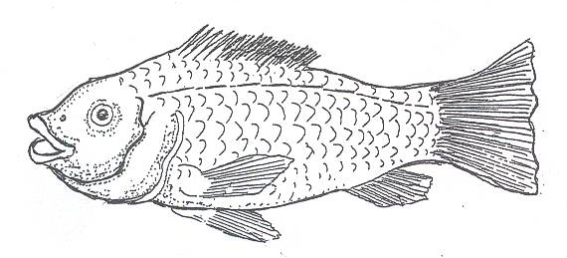

G

F

(a) Name the parts marked F and G.
(i)F __________________________(ii) G ______________________________
- How is E useful to a fish?
_________________________________________________________________
- How is the reproduction in the above animal different from that of goats?
__________________________________________________________________________________________________________________________________
END

